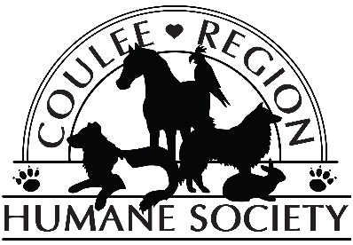
Coulee Region Humane Society
Community Service Application
This application is intended for individuals 18 years of age and older who need to fulfill court ordered community service hours. Eligible volunteers may not have any offenses pertaining to physical abuse of people or animals, battery, or illegal substance possession. The approval of the probation/diversion officer will also be needed. The Coulee Region Humane Society, Inc. (CRHS) CRHS reserves the right to terminate a volunteer’s association with the organization if it is determined that the volunteer violated CRHS policies or
Contact Volunteer Coordinator: megan.krueger@couleehumane.com or 608.781.4014
It will take up to 1 week for processing.
General Information:
First Name, Middle Initial, Last Name: Click here to enter text.
Address: Click here to enter text.
Birthday: Click here to enter text. Age: Click here to enter text.
Email Address (Required): Click here to enter text.
Phone Number: Click here to enter text.

Community Service Information:
Diversion/Probation Officer’s Name: Click here to enter text.
Have you volunteered with Coulee Region Humane Society before: Yes☐No☐
Address: Click here to enter text. City: Click here to enter text. State: Click here to enter text. Zip: Click here to enter text.
Phone: Click here to enter text.
What is the nature of your offense? Please Explain: Click here to enter text.
Number of Hours Required: Click here to enter text. Date Assigned: Click here to enter a date.
Available Hours:
Monday: Click here to enter text. N/A: ☐
Tuesday: Click here to enter text. N/A: ☐
Wednesday: Click here to enter text. N/A: ☐
Thursday: Click here to enter text. N/A: ☐
Friday: Click here to enter text. N/A: ☐
Saturday: Click here to enter text. N/A: ☐
Sunday: Click here to enter text. N/A: ☐

Please Note: Community service participants do not work directly with the animals at the shelter. The types of duties you can expect to perform are: Housekeeping/Laundry—this includes miscellaneous cleaning duties such as sweeping, mopping, folding and washing laundry and sorting newspapers. Grounds Maintenance—this includes mowing, raking, trash removal, watering plants, snow removal, etc.

Liability Waiver: I certify that the statements made on this application are true and have been given voluntarily. I understand that this information may be disclosed to other parties, including for such purposes as criminal background checks, and I release Coulee Region Humane Society, Inc. (CRHS) from any liability whatsoever for supplying such information. I also understand I will not be paid for my services as a volunteer. In consideration of CRHS accepting my application for participation in CRHS programs, I agree to release and hold harmless CRHS from and against any and all loss, damage, claims, liability, costs and expenses of any nature whatsoever, including without limitation, attorney’s fees and disbursements arising from or occasioned by my participation in CRHS programs. I understand the risks inherent in working in an environment with animals and I accept these risks. I agree that CRHS may photograph my participation in this program and I hereby release any such photographs to CRHS for use in its programs, publications, and purpose.

Signature: ___________________________________________ Date: _________________________

STAFF USE ONLY:
Contact Date:
Wisconsin Circuit Court
ASM
Notes

