Coulee Region Humane Society Kennel Sponsorship Program

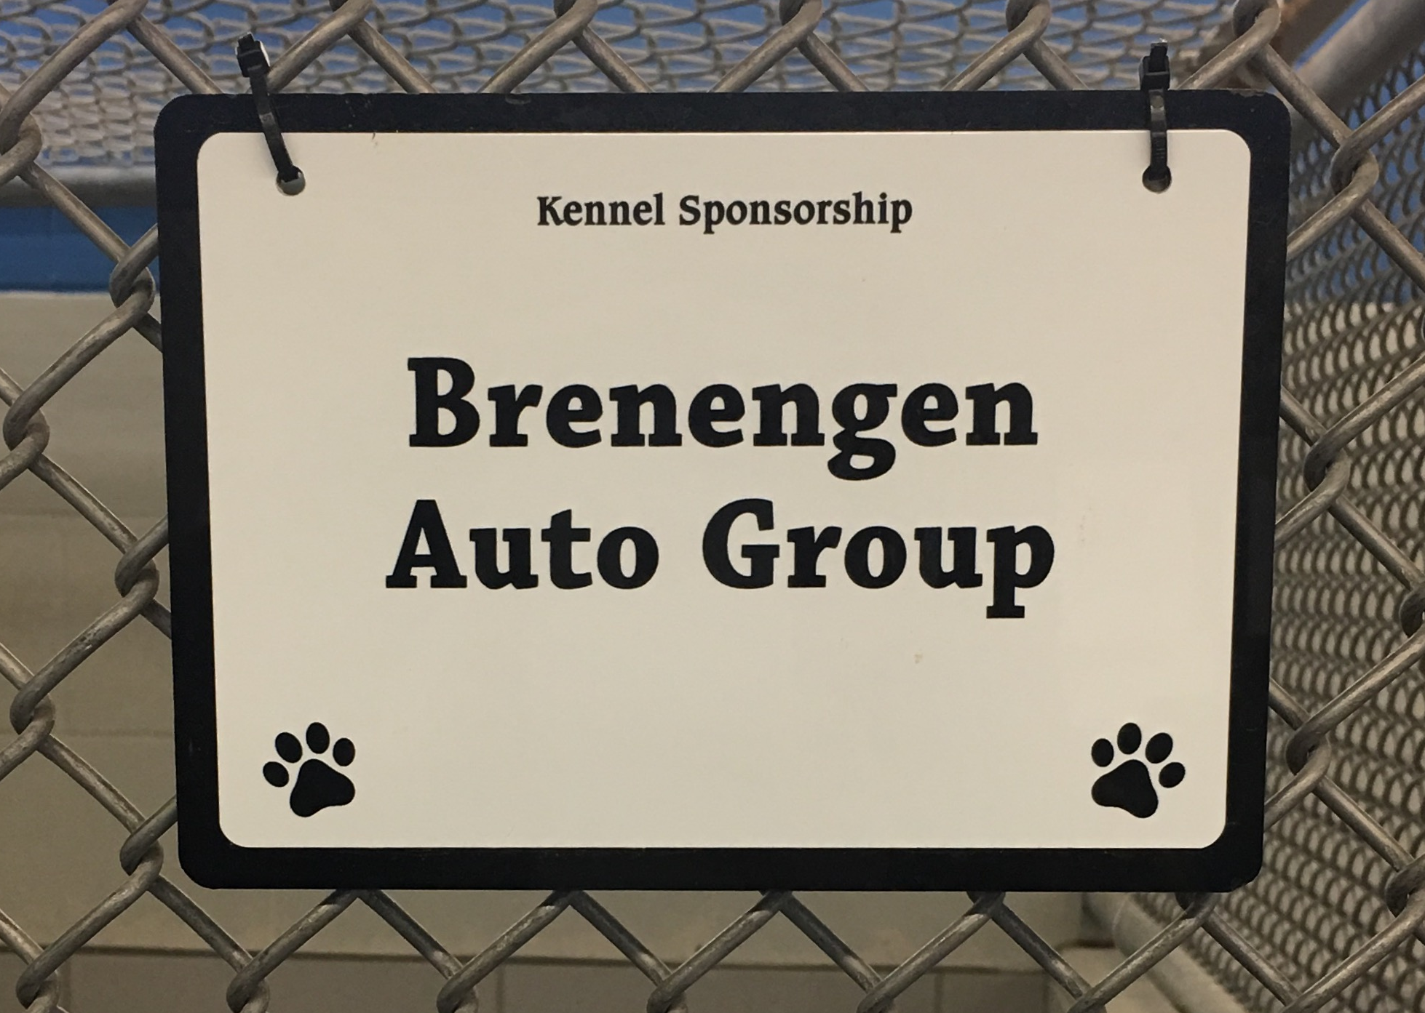
Our Kennel Sponsorship program provides a great opportunity for our community to directly support the animals we care for. You can symbolically “adopt” a dog or cat kennel for a tax deductible donation of $100 per month or $1,200 per year. If you have any questions about the Kennel Sponsorship Program, please call Taylor Bates at (608) 781-4014.

____ Annual Kennel Sponsorship: 3” x 5” plaque, $1,200 per year

____ Months at $100 per month: 3” x 5” plaque

I would like to sponsor: ____ Dog Kennel ____ Cat Kennel

Kennel Sign Inscription:

Signs can be in honor of yourself, your family, your friend, your company or even the name of a beloved pet.
Please print the name or message for your inscription in the space below. There is no limit to the number of characters available, however, the more you would like written the smaller the font will be.
Please note: Sponsorship will start the month after the completed sign has been received by our organization.

Name: _____________________________________ Phone: _______________________

Address: ____________________________________________________________________

City: _________________________ State: ________ Zip code: ____________
OFFICE USE ONLY:

Date Paid: Amount Paid: Method of Payment:

